***Use Case Diagram, Activity Diagram, Sequence Diagram, Communication Diagram, State Chart Diagram and Class Diagram for Vendor Machine***

**USE CASE:**

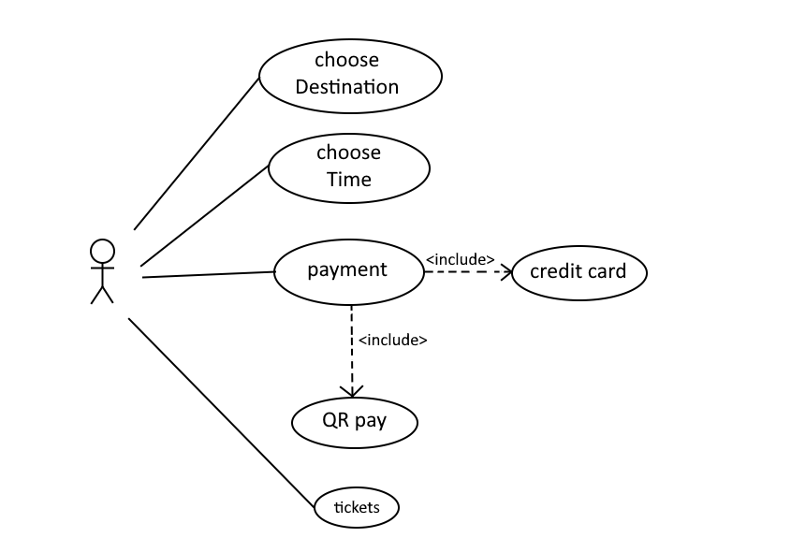

**ATIVITY DIAGRAM:**

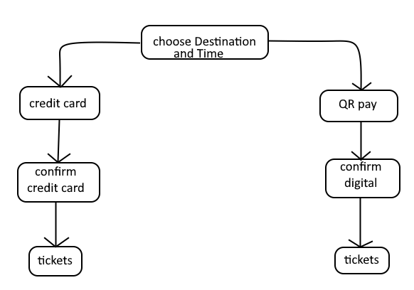

**SEQUENCE DIAGRAM:**

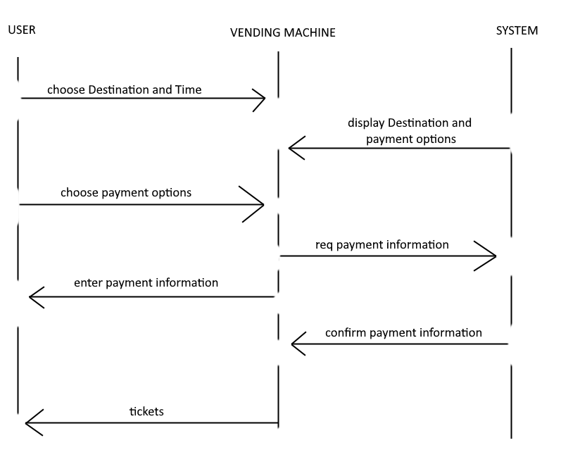

**COMMUNICATION DIAGRAM:**

